Title: VulnHub CTF Report – mhz_cxf: c1f
Objective
Obtain user-level and root-level flags through structured enumeration, exploitation, and privilege escalation.
Tools
Netdiscover, Nmap, dirb, SSH, SCP, Steghide
Methodology
Network Discovery
netdiscover identified the target at 192.168.1.104.

Port Scanning
nmap -p- -A 192.168.1.104
Revealed ports 22 and 80 open.

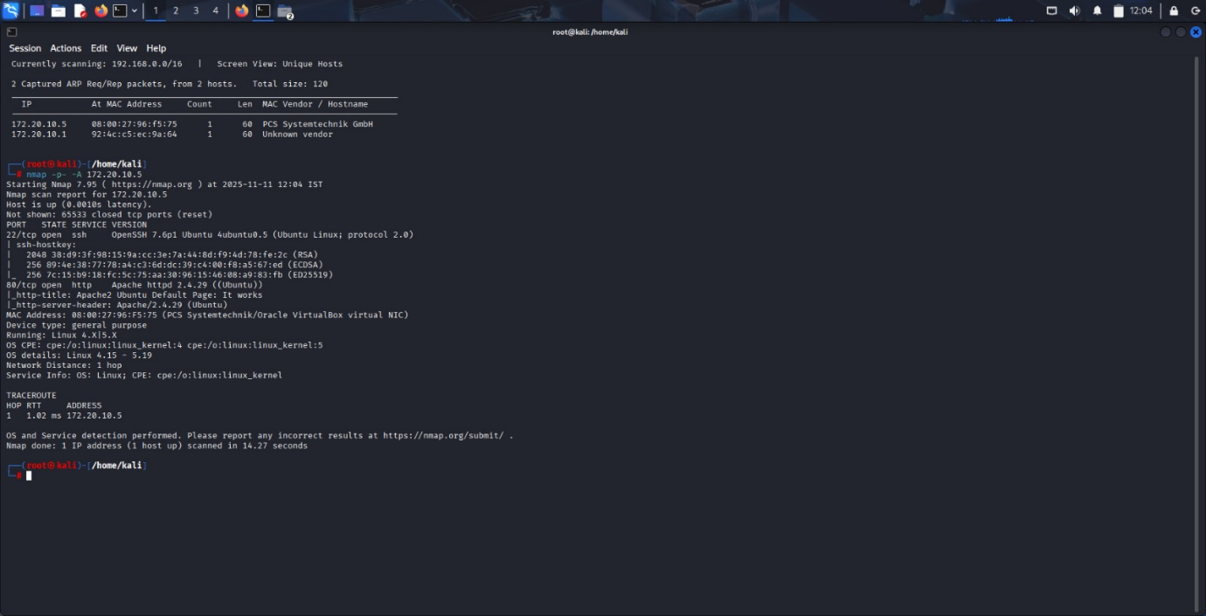

Enumeration
Directory brute-force using:
dirb http://192.168.1.104/ -X .txt
Located notes.txt, remb.txt, and potential credentials.
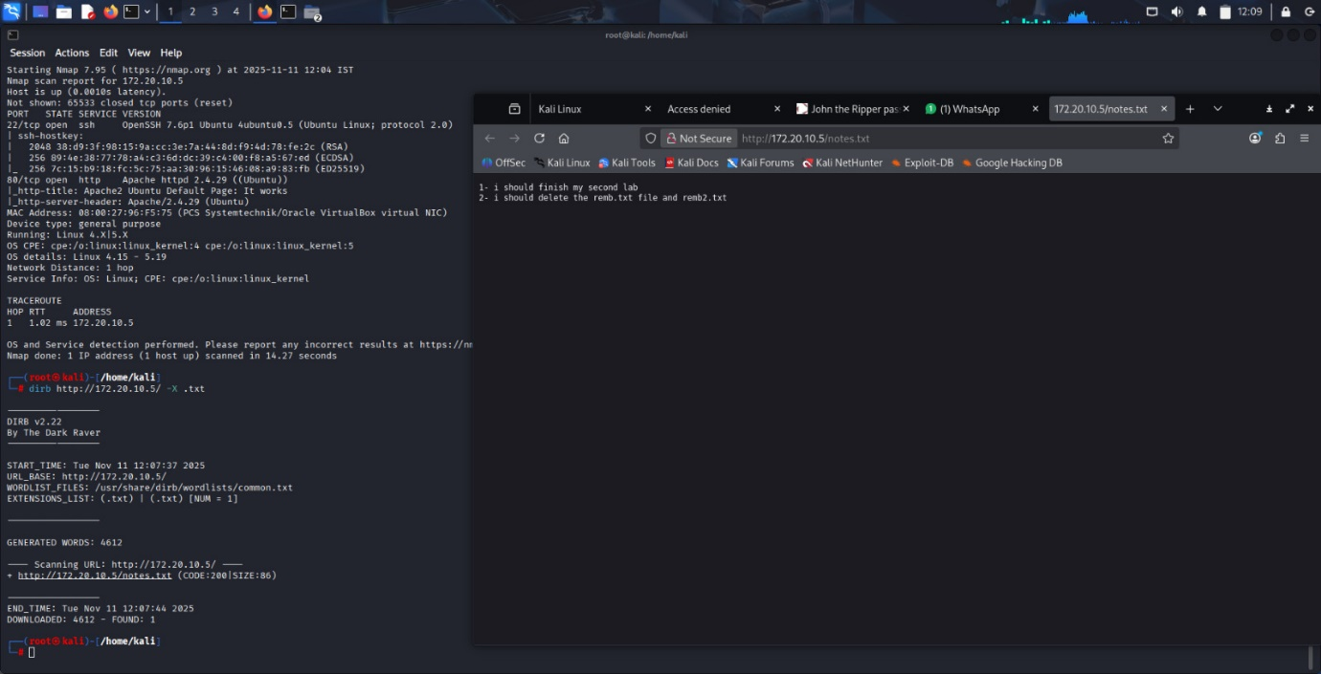
System Access
SSH login using recovered credentials:
ssh first_stage@192.168.1.104
Password: flagitifyoucan1234
Located user.txt and image directory.

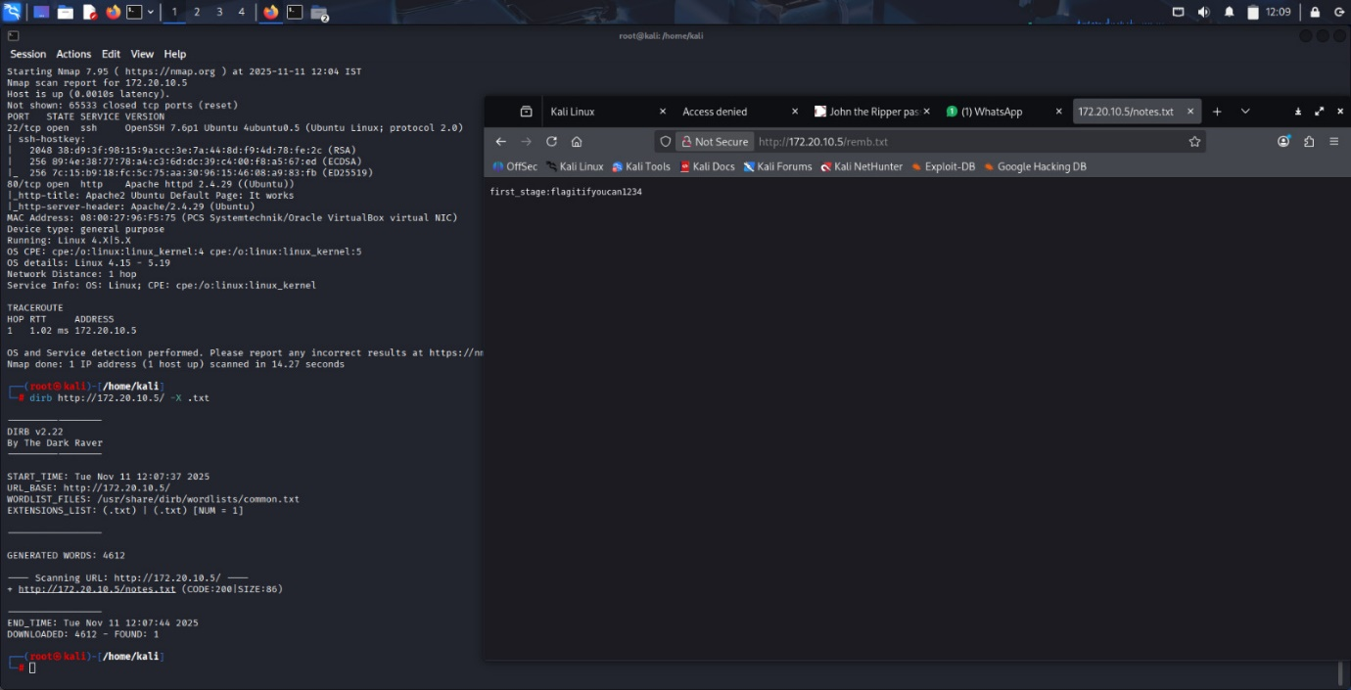
Data Exfiltration
Used SCP to pull all image files from the victim:
mkdir raj
cd raj
scp first_stage@192.168.1.104:/home/mhz_c1f/Paintaings/* .
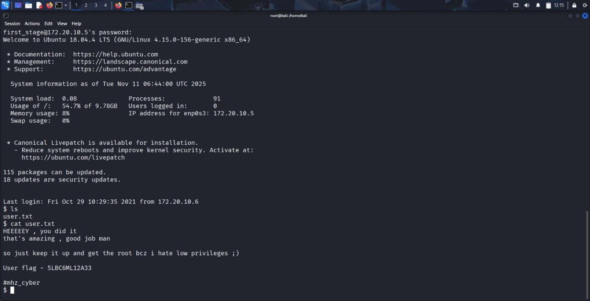

Steganography
Extracted hidden text from images:
steghide extract -sf "spinning the wool.jpeg"
Recovered remb2.txt with additional credentials. 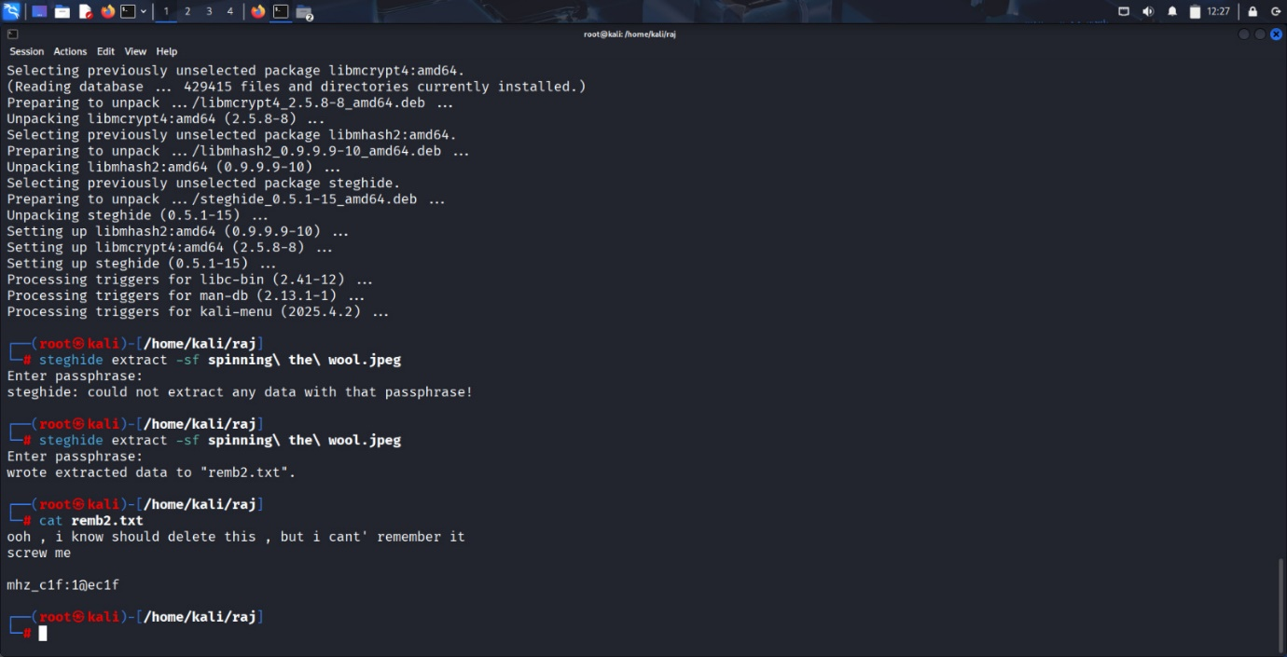
Privilege Escalation
Switched to the next user:
su mhz_c1f
Checked group membership:
id
Used sudo to escalate:
sudo su
Navigated to root and retrieved flag:
cd /root
cat .root.txt
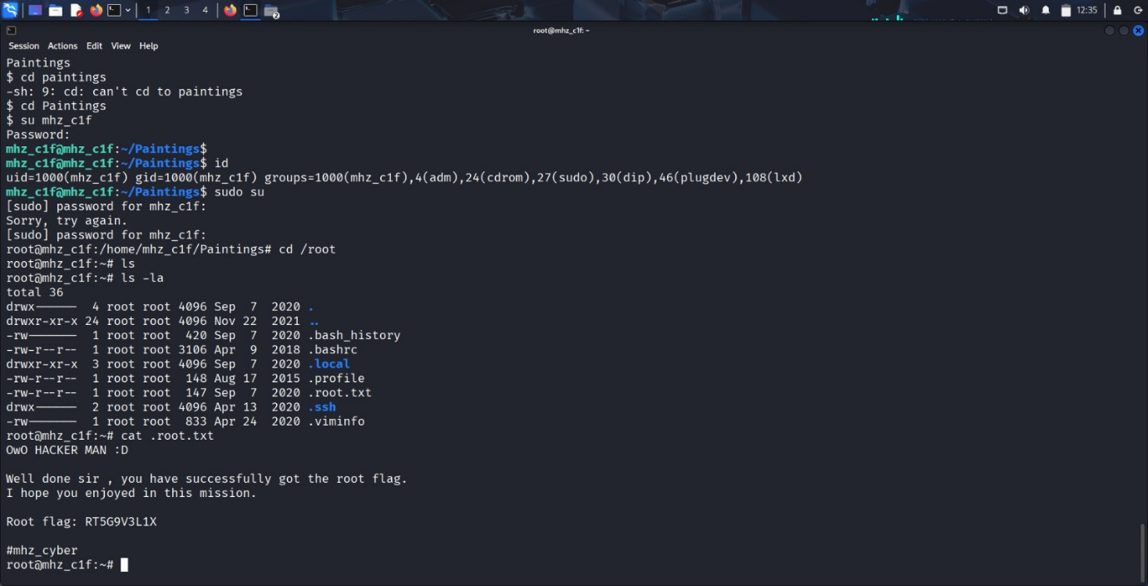
Conclusion
The machine exposes a clear chain: weak directory protection, credential leakage, accessible SSH, hidden data embedded via steganography, and misconfigured sudo privileges. Enumeration, controlled data extraction, and local privilege escalation provide complete compromise.

